A
PROJECT REPORT
ON
TEXT EDITOR IN JAVA
Submitted in Partial Fulfillment for the Award of
Bachelor of Technology Degree
Of
Rajasthan Technical University, Kota
(2010-2011)

Preface

This project was undertaken at NETMax Technologies, CHANDIGARH during industrial training engineering to automate the system .The project is named as TEXT EDITOR.

The purpose of this report is to assemble under one cover a sufficient body of knowledge about management and development a successful software engineering project. The following quotes outline the basic idea behind this technical report.

This report is about the adaptation of the techniques of project development and reflects the practice and methods of software engineering project this report is intended for:

• Project managers—the report delivers the necessary information of the process a software development project
• Project coordinators —the tutorial presents the state of the practice in software development and management techniques.
• Software engineers, programmers, analysts, and other computer personnel —the report contains a general description of—and problems in—software engineering project development, plus a number of methodologies and techniques for managing a software development project.

INTRODUCTION

The project is based on “Text Editor”. This project is carried out at Netmax Technologies. This software firm deals in developing software for its clients.

Text Editor: - A text editor is a type of program used for editing plain text files. A plain text file is represented and edited by showing all the characters as they are present in the file. The only characters usable for 'mark-up' are the control characters of the used character set; in practice this is newline, tab and form feed. The most commonly used character set is ASCII, especially recently, as plain text files are more often being used for programming and configuration, and less frequently for documentation (e.g. detailed instructions, user guides) than in the past.

Features
Our text editor provides basic features of an editor.

- String searching - search string with by typing it in search string.
- Cut, copy, and paste - most text editors provide methods to duplicate and move text within the file, or between files.
- Multiple font colors – The editor provides 4 different font colors to make a text more interactive and attractive.
- Fonts – the editor provides all fonts that can be used to make a text more appealing.
- Dock- the editor provides a very interactive graphical user interface in which there is a dock. The dock consist those options which are in frequent use for e.g. cut, copy, paste etc.

Project Overview

Project Name | : | Text Editor
Institute | : | Netmax Technologies
Project Type | : | Development Project
Front End | : | Java swings, AWT.
Tools | : | Notepad Editor, Edit Plus 3.

This project “Text Editor” is software which can edit plain text. It is made using Java Swings and AWT.
In this project all the frames are designed in Swing. Today most programmers use Swing. Swing is a set of classes that provides more powerful and flexible GUI components than does the AWT. Swing provides the look and feel of the modern Java GUI.

Swing did not exist in the early days of Java. Rather, it was a response to deficiencies present in Java’s original GUI subsystem: the Abstract Window Toolkit. The AWT defines a basic set of controls, windows, and dialog boxes that support a usable, but limited graphical interface.

System development life cycle (SDLC)
This is also known as Classic Life Cycle Model (or) Linear Sequential Model (or) Waterfall Method. This has the following activities.
1. System/Information Engineering and Modeling

2. Software Requirements Analysis

3. Systems Analysis and Design

4. Code Generation

5. Testing

6. Maintenance

System/Information Engineering and Modeling
As software is always of a large system (or business), work begins by establishing requirements for all system elements and then allocating some subset of these requirements to software. This system view is essential when software must interface with other elements such as hardware, people and other resources. System is the basic and very critical requirement for the existence of software in any entity. So if the system is not in place, the system should be engineered and put in place. In some cases, to extract the maximum output, the system should be re-engineered and spruced up. Once the ideal system is engineered or tuned, the development team studies the software requirement for the system.

Software Requirement Analysis
This is also known as feasibility study. In this phase, the development team visits the customer and studies their system. They investigate the need for possible software automation in the given system. By the end of the feasibility study, the team furnishes a document that holds the different specific recommendations for the candidate system. It also includes the personnel assignments, costs, project schedule, and target dates. The requirements gathering process is intensified and focused specially on software. To understand the nature of the program(s) to be built, the system engineer ("analyst") must understand the information domain for the software, as well as required function, behavior, performance and interfacing. The essential purpose of this phase is to find the need and to define the problem that needs to be solved.

System Analysis and Design
In this phase, the software development process, the software's overall structure and its nuances are defined. In terms of the client/server technology, the number of tiers needed for the package architecture, the database design, the data structure design etc are all defined in this phase. A software development model is created. Analysis and Design are very crucial in the whole development cycle. Any glitch in the design phase could be very expensive to solve in the later stage of the software development. Much care is taken during this phase. The logical system of the product is developed in this phase.
Code generation
The design must be translated into a machine-readable form. The code generation step performs this task. If the design is performed in a detailed manner, code generation can be accomplished without much complication. Programming tools like Compilers, Interpreters, and Debuggers are used to generate the code. Different high level programming languages like C, C++, Pascal, and Java are used for coding. With respect to the type of application, the right programming language is chosen

Testing
Once the code is generated, the software program testing begins. Different testing methodologies are available to unravel the bugs that were committed during the previous phases. Different testing tools and methodologies are already available. Some companies build their own testing tools that are tailor made for their own development operations.
Maintenance
Software will definitely undergo change once it is delivered to the customer. There are many reasons for the change. Change could happen because of some unexpected input values into the system. In addition, the changes in the system could directly affect the software operations. The software should be developed to accommodate changes that could happen during the post implementation period.

Java
Java is a programming language originally developed by James Gosling at Sun Microsystems (which is now a subsidiary of Oracle Corporation) and released in 1995 as a core component of Sun Microsystems' Java platform. The language derives much of its syntax from C and C++ but has a simpler object model and fewer low-level facilities. Java applications are typically compiled to byte code (class file) that can run on any Java Virtual Machine (JVM) regardless of computer architecture. Java is a general-purpose, concurrent, class-based, object-oriented language that is specifically designed to have as few implementation dependencies as possible. It is intended to let application developers "write once, run anywhere". Java is currently one of the most popular programming languages in use, and is widely used from application software to web applications.
The original and reference implementation Java compilers, virtual machines, and class libraries were developed by Sun from 1995.

History
James Gosling, Mike Sheridan, and Patrick Naughton initiated the Java language project in June 1991. Java was originally designed for interactive television, but it was too advanced. The language was initially called Oak after an oak tree that stood outside Gosling's office; it went by the name Green later, and was later renamed Java, from a list of random words. Gosling aimed to implement a virtual machine and a language that had a familiar C/C++ style of notation.
Sun Microsystems released the first public implementation as Java 1.0 in 1995. It promised "Write Once, Run anywhere" (WORA), providing no-cost run-times on popular platforms. Fairly secure and featuring configurable security, it allowed network- and file-access restrictions. Major web browsers soon incorporated the ability to run Java applets within web pages, and Java quickly became popular. With the advent of Java 2 (released initially as J2SE 1.2 in December 1998–1999), new versions had multiple configurations built for different types of platforms. For example, J2EE targeted enterprise applications and the greatly stripped-down version J2ME for mobile applications (Mobile Java). J2SE designated the Standard Edition. In 2006, for marketing purposes, Sun renamed new J2 versions as Java EE, Java ME, and Java SE, respectively.
Sun make most of its Java implementations available without charge, despite their proprietary software status. Sun generated revenue from Java through the selling of licenses for specialized products such as the Java Enterprise System. Sun distinguishes between its Software Development Kit (SDK) and Runtime Environment (JRE) (a subset of the SDK); the primary distinction involves the JRE's lack of the compiler, utility programs, and header files.
On November 13, 2006, Sun released much of Java as open source software under the terms of the GNU General Public License (GPL). On May 8, 2007, Sun finished the process, making all of Java's core code available under free software/open-source distribution terms, aside from a small portion of code to which Sun did not hold the copyright.
Following Oracle Corporation's acquisition of Sun Microsystems in 2009-2010, Oracle has described itself as the "steward of Java technology with a relentless commitment to fostering a community of participation and transparency".
Characteristics:-
- Simple
- Object oriented
- Distributed
- Interpreted
- Robust
- Secure
- Architecture neutral
- Portable
- High performance
- Multithreaded
With most programming languages, you either compile or interpret a program so that you can run it on your computer. The Java programming language is unusual in that a program is both compiled and interpreted. With the compiler, first you translate a program into an intermediate language called Java byte codes —the platform-independent codes interpreted by the interpreter on the Java platform. The interpreter parses and runs each Java byte code instruction on the computer. Compilation happens just once; interpretation occurs each time the program is executed. The following figure illustrates how this works.

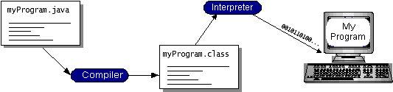

Figure 1: Java programming steps

You can think of Java byte codes as the machine code instructions for the Java Virtual Machine (Java VM). Every Java interpreter, whether it's a development tool or a Web browser that can run applets, is an implementation of the Java VM.

Java byte codes help make "write once, run anywhere" possible. You can compile your program into byte codes on any platform that has a Java compiler. The byte codes can then be run on any implementation of the Java VM. That means that as long as a computer has a Java VM, the same program written in the Java programming language can run on Windows 2000, a Solaris workstation, or on an iMac.

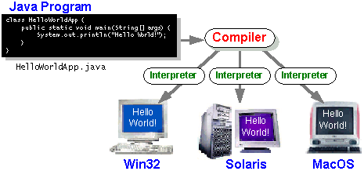

Figure 2: write once run everywhere
The Java Platform

A platform is the hardware or software environment in which a program runs. We've already mentioned some of the most popular platforms like Windows 2000, Linux, Solaris, and Mac OS. Most platforms can be described as a combination of the operating system and hardware. The Java platform differs from most other platforms in that it's a software-only platform that runs on top of other hardware-based platforms.

The Java platform has two components:

- The Java Virtual Machine (Java VM)
- The Java Application Programming Interface (Java API)

Java Virtual Machine is standardized hypothetical computer, which is emulated inside our computer by a program. It is base of Java platform and is ported onto various hardware-based platforms.
The Java API is a large collection of ready-made software components that provide many useful capabilities, such as graphical user interface (GUI) widgets. The Java API is grouped into libraries of related classes and interfaces; these libraries are known as packages.

The following figure depicts a program that's running on the Java platform. As the figure shows, the Java API and the virtual machine insulate the program from the hardware.

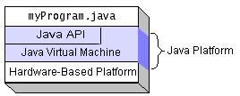

Figure 3 Java API

What Can Java Technology Do…?

The most common types of programs written in the Java programming language are applets and applications. If you've accessed the Web, you're probably already familiar with applets. An applet is a program that adheres to certain conventions that allow it to run within a Java-enabled browser.

However, the Java programming language is not just for writing cute, entertaining applets for the Web. The general-purpose, high-level Java programming language is also a powerful software platform. Using the generous API, you can write many types of programs.

An application is a standalone program that runs directly on the Java platform. A special kind of application known as a server serves and supports clients on a network. Examples of servers are Web servers, proxy servers, mail servers, and print servers. Another specialized program is a servlet. A servlet can almost be thought of as an applet that runs on the server side. Java Servlets are a popular choice for building interactive web applications, replacing the use of CGI scripts. Servlets are similar to applets in that they are runtime extensions of applications. Instead of working in browsers, though, servlets run within Java Web servers, configuring or tailoring the server.

JFC and Swing

JFC and Swing is a part of java extension. JFC is short for Java Foundation Classes, which encompass a group of features to help people build graphical user interfaces (GUIs). The JFC was first announced at the 1997 Java One developer conference and is defined as containing the following features:

- The Swing Components

Include everything from buttons to split panes to tables.

- Pluggable Look and Feel Support

It gives any program that uses Swing components a choice of looks and feels. For example, the same program can use either the Java look and feel or the Windows look and feel. We expect many more look-and-feel packages -- including some that use sound instead of a visual "look" -- to become available from various sources.

- Accessibility API

It enables assistive technologies such as screen readers and Braille displays to get information from the user interface.

- Java 2DTM API (Java 2 Platform only)

It enables developers to easily incorporate high-quality 2D graphics, text, and images in applications and in applets.

- Drag and Drop Support (Java 2 Platform only)

Provides the ability to drag and drop between a Java application and a native application.
The Swing API is available in two forms:
- As a core part of the Java 2 Platform, Standard Edition (including versions 1.2, 1.3, and 1.4)
- JFC 1.1 (for use with JDK 1.1)
Sun community recommends that to use the latest version of the Java 2 Platform. Not only will you be getting the latest bug fixes, but you'll get more features. (As we used JSDK1.5.0_01 version, which is the latest release of java development kit up to the time of written of this report.)

SNAPSHOTS

1. Main window
This is the GUI of text editor it includes the dock under the menu bar and text space for editing the text. The look and feel is default look of Operating system.
This window appears when we run the editor.java in command prompt.
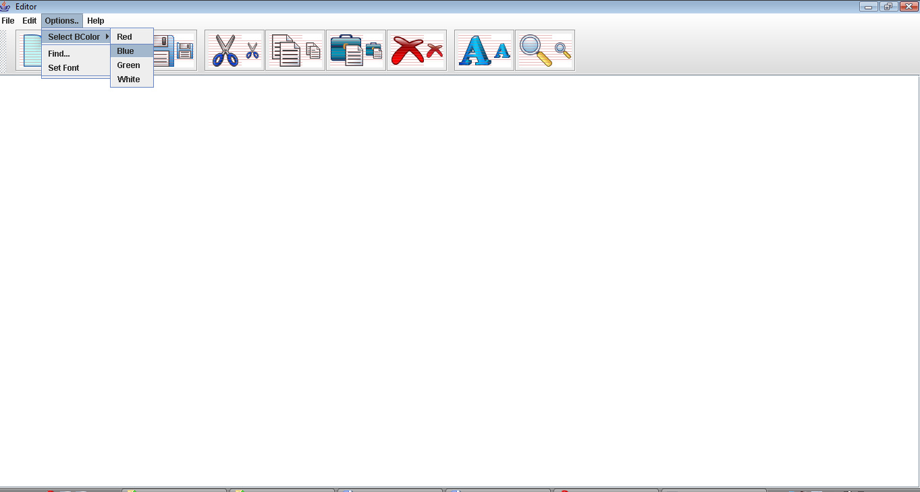

Figure 4: main window

2. Opening a file
This window appears when we click on the open option on the Dock or in the file menu
The file menu is created using JMenu class.

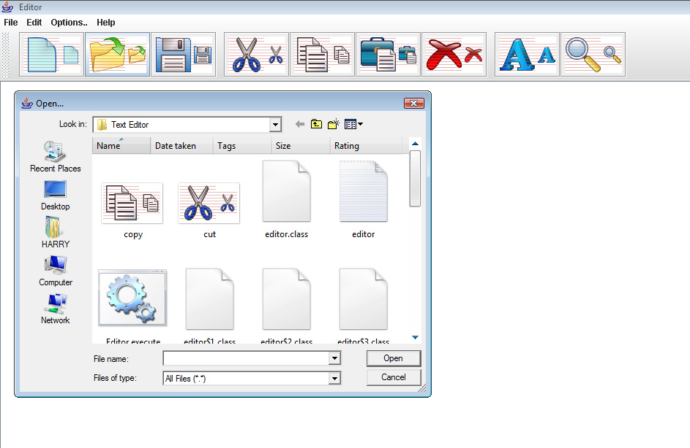

Figure 5: Opening a file

3. Saving a file

This window appears when we want to save the file. The shortcut Ctrl+s do not work here so we can do it using file menu or option on the Dock.

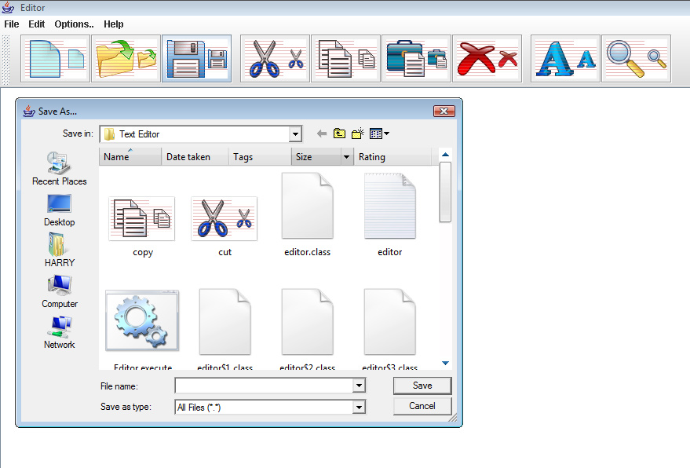
Figure 6: Saving a file

4. Fonts

This menu appears when we want to select the font. This is named as font selector.

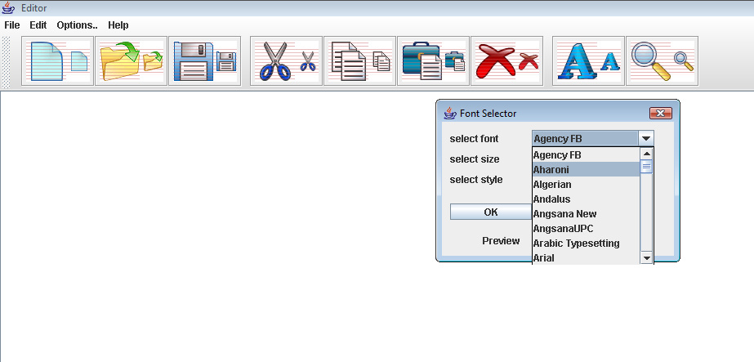

Figure 7: Fonts

Conclusions

This project that I undertook was truly a very rewarding experience for me in more than one way. It has given a big thrust to my technical knowledge as prospective Software professional. It has also helped me enhance my skills on the personal front.

And I feel extremely satisfied by the fact that I have managed to develop the project of course with equal contribution from my team members. I think I have exploited the opportunity that came my way to the fullest extent by increasing my technical know-how and also gaining the valuable work experience apart from studying the other subjects in our curriculum.

Bibliography

The referred books were
1. Java 2-Complete reference (5th edition) by Herbert Schildt
2. Thinking in Java by Bruce Eckel.

And the following websites were also used for reference
1. http://en.wikipedia.org/wiki/Java_(programming_language)/
2. http://download.oracle.com/javase/tutorial/
3. http://www.developer.com/java/
4. http://java.sun.com/docs/books/tutorial
5. http://www.cafeaulait.org/course/
6. http://oopweb.com/Java/Documents/IntroToProgrammingUsingJava/VolumeFrames.html

TABLE OF CONTENTS

Nomenclature Page no.
Certificate i
Acknowledgement ii
List of figures iii
Table of contents iv

1. Preface 1
2. Introduction 2
3. Project Overview 3
4. SDLC 4-
  - System/Information Engineering and Modeling 4
  - Software Requirements Analysis 4
  - Systems Analysis and Design 5
  - Code Generation 5
  - Testing 5
4.6 Maintenance 5

5. Java 6-
5.1 History 6
5.2 characteristics 7
5.3 The Java Platform 8
5.4 What can java do? 9
5.5 JFC and Swings 10
6. Snapshots 12-
6.1 Main window 12
6.2 opening a file 13
6.3 Saving a file 14
6.4 Fonts 15
7. Conclusion 16
8. Bibliography 17

LIST OF FIGURES

Figure Page no.

1. Java programming steps 7
2. Write once run everywhere 8
3. Java API 9
4. Main window 12
5. Opening a file 13
6. Saving a file 14
7. Fonts 15

